Lesson 4
Trigonometric Functions
of Any Angle

sPECIFIC OBJECTIVES:
At the end of the lesson, the student is expected to:
- Determine the sign of a trigonometric function in any of the four quadrants.
- Determine the six trigonometric functions from a point on the terminal side of an angle in any quadrant.
- Determine the reference angle for an angle whose terminal side lies in any quadrant.
- Find the value of the trigonometric functions for any given angle.

3.1 Quadrants

Definition 3.1 Quadrants

The coordinate axes divide the plane into four parts called quadrants. For any given angle in standard position, the measurement boundaries for each quadrant are summarized as follows:

Quadrant II y Quadrant I

( - , + ) ( + , + )

90°< < 180° 0°< < 90°

x

Quadrant III Quadrant IV

( - , - ) ( + , - )

180°< < 270° 270°< < 360°

The signs of x and y in each of the various quadrants are also shown in the above figure.

Example 3.1 Determine the quadrant where the terminal side of each angle lie when it is standard position.

a) 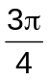 c) 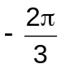
b) 125° d) 197°

3.2 Trigonometric Functions of Any Angle

If is an angle in standard position, P( x, y ) is any point other than the origin on the terminal side of , and 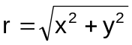, then

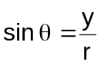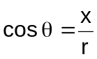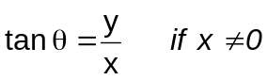

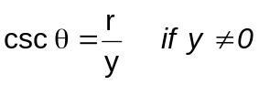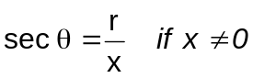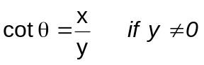

y

P

r
y

x

Remarks:

- When x = 0, tan and sec are not defined, and when y = 0, csc and cot are not defined.
- A second, third, or fourth quadrant angle means that the terminal side of the angle lies in the second, third, or fourth quadrant respectively.

Example 3.2 The terminal side of angle in standard position passes through P. Draw and find the exact values of the six trigonometric functions of .

a) P (-3, -3 ) c) P ( 2, -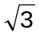 )
b) P ( -5, 12 ) d) P ( 24, - 7)

3.3 Signs of the Trigonometric Functions

Each of the trigonometric functions of an angle is given by two of the variables x, y and r associated with . Because r is always positive, the sign ( + or - ) of a trigonometric function is determined by the signs of x and y, and therefore by the quadrant containing .

The sign of each trigonometric function in each quadrant are summarized below.

Function | I | II | III | IV
Sine | + | + | - | -
Cosine | + | - | - | +
Tangent | + | - | + | -
Cotangent | + | - | + | -
Secant | + | - | - | +
Cosecant | + | + | - | -

Remark:

Graphically, the figure below summarizes the quadrants where each trigonometric function is positive.
y

sin All
functions
csc
x

tan cos

cot sec

Example 3.3.1 Determine the sign of the following trigonometric functions without the aid of a calculator.

a) cot 135° c) sec 187.3°
b) csc 301° d) cos 107°

Example 3.3.2 Find the quadrant(s) where the following conditions are true:

a) sin < 0 , cos < 0 d) sin < 0 , tan > 0
b) sin > 0 , cos < 0 e) sec < 0 , csc < 0
c) sec < 0 , cot > 0 f) sin , cos and tan all have
the same sign

Example 3.3.3 Find the exact values of the other five trigonometric functions for an angle in standard position lying in the given quadrant.

a) 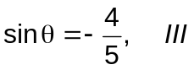 c) 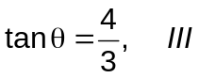
b) 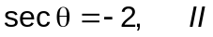 d) 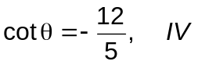
3.4 Evaluation of Trigonometric Functions of Any Angle

Definition 3.4 Quadrantal Angles

An angle in standard position whose terminal side lies on the x- or y- axis is called a quadrantal angle. The definitions of the trigonometric functions can be used to evaluate the trigonometric functions of the quadrantal angles 0°, 90°, 180°, 270° and 360° by using r equal to 1.

Exercise 3.4 Find the six trigonometric functions of 0°, 90°, 180°, 270° and 360° by using the definitions of the trigonometric functions and r = 1.

Definition 3.4.2 Reference Angle

The reference angle 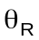of any angle is the positive angle formed by the terminal side of the angle and the nearest x-axis.

Remarks:

- The reference angle is always the positive angle measured between the terminal side of the angle and the nearest angle.
- A summary of how to calculate the reference angle from a given angle is given below:

Quadrant I =
Quadrant II = 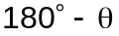
Quadrant III = 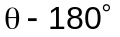
Quadrant IV = 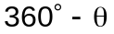

Example 3.4.1 Give the measure of the reference angle for each of the angle in standard position:

a) 171° c) -110°
b) 505° d) 325°

Example 3.4.2 Find the exact values of the six trigonometric functions for each of the following angle without the aid of the calculator.

a) 135° c) 210°
b) 390° d) 